Technical Datasheet for Noise Detection Sensor with RS485

WIN-SN-NOISE-M is a versatile and reliable solution for anyone needing precise acoustic and ambient noise monitoring with robust communication capabilities. It measures noise levels in various environments, from industrial facilities to smart buildings and urban monitoring stations. This board communicates readings through an RS485 Modbus interface. This type of communication is robust, making it ideal for long-distance data transmission and resistant to electrical interference, ensuring accurate and reliable measurements.

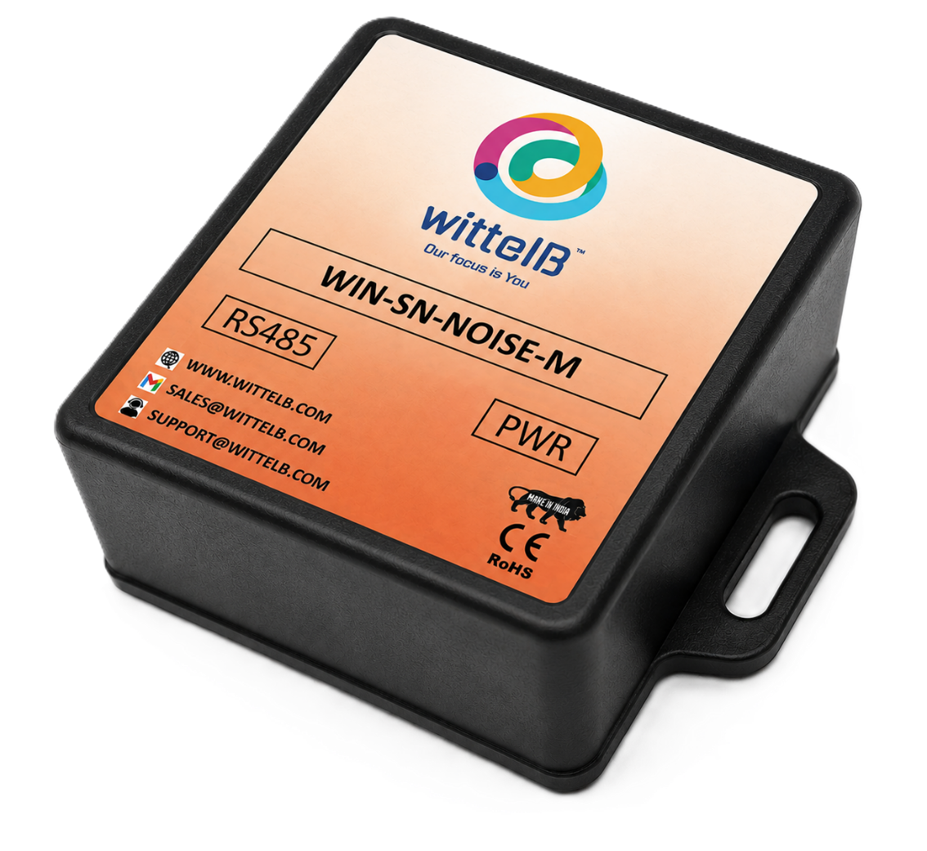
Sensor Node Module: -

This manual provides instructions for installation and use of the sensor board to measure Noise in the environment. The sensor board offers data output in Modbus RTU (RS485) and can be powered by DC power supply.

The design of the modules incorporates ‘resettable Fuses’ to safeguard against reverse polarity connection for Power port.

Specifications
General:-
- Wide temperature range: −20 °C to +85 °C
- Full humidity range: 0 % to 100 % RH
- Power supply DC: 12-24V@1A.

- Product dimension: 40*40*20 mm

- Certifications:

Power Supply Connection
DC Connection
- Use 12-24V@ 1A, Power supply.
- Don’t make loose connection.

Additional Features: -
All inputs and communication ports isolated
Input power reverse polarity safety
ESD Safety IEC 61000-4-2, ± 30KV contact, ± 30KV air
EFT IEC 61000-4-4, 50A (5/50ms)
750V isolation.
CRC Error check.
No configuration needed on the IO board

Configuration Settings
- Communication Speed 9600 – 115200 Kbps (SW Selectable)
- Data Bits 8
- Parity None
- CRC Yes
- Slave ID 1, DIP (SW Selectable)
- Function Code 0X03 (Read Holding Register)

Modbus RS485 Data Storage register

ID | Function  Description | Register  Description | Modbus Function Code | Protocol | Data  Type
1 | 10 Bit Resolution | 40001 | 0x03 | RS485 | 16-bit int
2 | dB Values (0 - 130 dBm) | 40002 | 0x03 | RS485 | 16-bit int
3 | Display Baud Rate (Default: 960) | 40011 | 0x03 | RS485 | 16-bit int
4 | Enter New Baud Rate | 40012 | 0x03 | RS485 | 16-bit int
5 | Display Slave ID (Default: 1) | 40013 | 0x03 | RS485 | 16-bit int
6 | Enter New Slave ID | 40014 | 0x03 | RS485 | 16-bit int
7 | Display Parity (Default: None-3 And for Odd-1, Even-2) | 40015 | 0x03 | RS485 | 16-bit int
8 | Enter New Parity | 40016 | 0x03 | RS485 | 16-bit int
9 | Display Stop Bit (start-2/stop bit-1) | 40017 | 0x03 | RS485 | 16-bit int
10 | Enter New Start/ Stop Bit | 40018 | 0x03 | RS485 | 16-bit int

Modbus Configuration
Here is an example of receiving data on Mb poll software.
- Open Mb-poll software connects using configuration setting (Default baud rate is 9600 and slave id is 1).
- After connecting you will get data as shown below.
Important Note
- If you want to enter the baud rate 9600/19200/38400/57600/115200etc, enter it like this 960/1920/3840/5760/11520etc.
- After that press the reset button or reboot the system.
- Then you will get the present value of 11520 at 40011 baud rate (115200) and 2 at 40013 slave id.
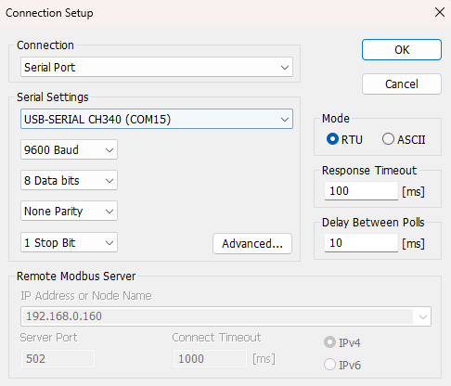
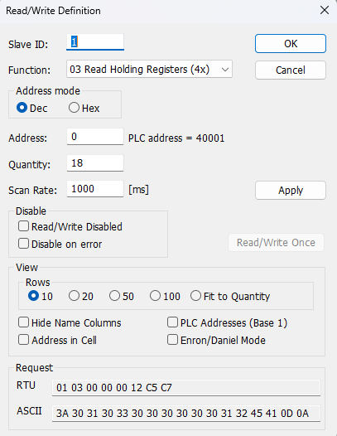

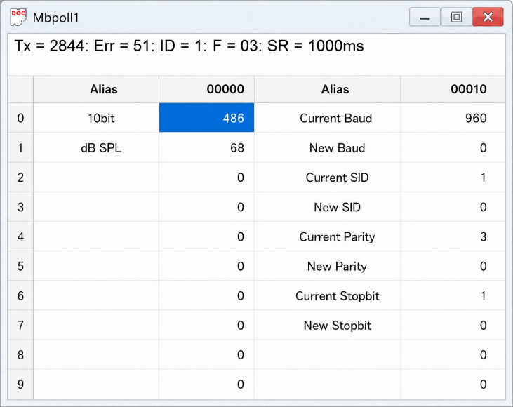
- Above image Shows sensor data over Modbus with default Modbus settings
- At register 40001 shows Temperature Values.
- The value 320 indicates 32.0 temperature.
- As you can see in the image above, the resistor 40011 – 960 represents the present bund rate (9600) of the board and 40013 – 1 represents the present slave id of the board.
- To change the baud rate and slave id Jumper should be in single/removed then, you must enter a value on the 40012 resistors for the baud rate and 40014 for the slave id as shown in the image below and restart the board.
- Now you can see data below image set 115200 baud rate and slave ID 10.
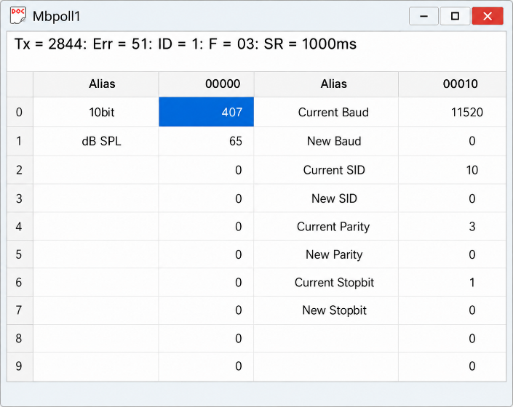
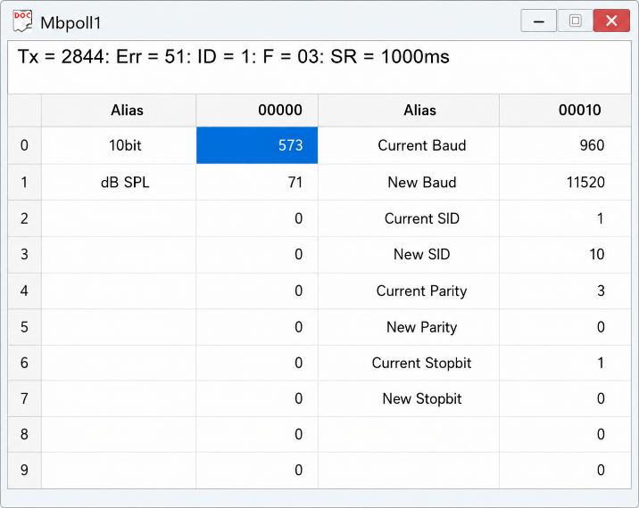

Hard reset Setting
- Somehow you forgot the baud rate or slave id of the board then Place the jumper and reboot the board it will go back to default [Salve ID: 1] and [Baud Rate: 9600]

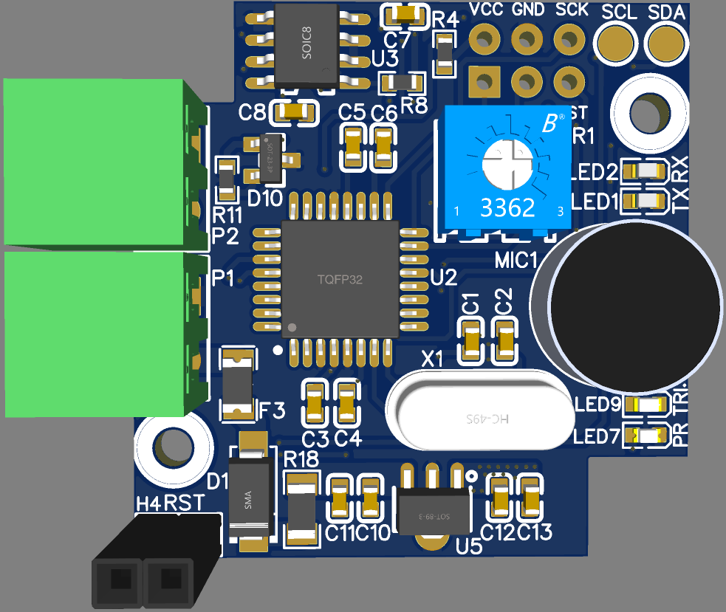
Noise Sensitivity Calibration
Pooling LEDs
Power & Trigger LEDs
MIC
Modbus RS485 Port
Input Supply 24V DC
Reset SW

Contact us: -
Augmatic Technologies Pvt. Ltd.,
Plot no 6, Shah Industrial Estate II,
Kotambi,
Vadodara – 391510.
Email – Sales@wittelb.com
Support: support@wittelb.raiseaticket.com / +91 94038 92805

